**Incidence and In Hospital Mortality of Acute Circulatory Support Prior to Heart Transplantation**

**Running Title: Circulatory Support Prior to Transplant**

David Ouyang, MD1, Gunsagar Gulati1, Richard Ha2, Dipanjan Banerjee, MD MS1

1. Stanford University School of Medicine, Stanford, CA 94305, USA. 2.Division of Adult Cardiac Surgery, Department of Cardiothoracic Surgery.

**Address for Correspondence:**Dipanjan Banerjee, MD MS

300 Pasteur Dr MC 5319

A260

Stanford, CA94305

Tel: (650) 723-6459

Fax: (650) 723-8392 **Email:** dipanjan@stanford.edu

**Background**: Proposed changes to the UNOS heart transplant allocation protocol would prioritize patients receiving acute circulatory support, including extracorporeal membrane oxygenation (ECMO), percutaneous ventricular assist devices (PVAD), and intra-aortic balloon pumps (IABP). We sought to evaluate contemporary trends in the incidence and outcomes of patients who required acute circulatory support during the hospitalization prior to heart transplantation.

**Methods**: Using the Nationwide Inpatient Sample (NIS) from 1998 to 2011, we identified 5,381 patients who underwent orthotopic heart transplant (OHT) and determined whether the patient underwent pre-transplant ECMO, PVAD, or IABP. We calculated baseline characteristics and in hospital outcomes of patients who underwent acute circulatory support compared to patients who did not require acute circulatory support prior to heart transplantation.

**Results**: Of patients who underwent heart transplantation, 337 (6.3%) patients received acute circulatory support prior to transplant. During the study time period, the use of acute circulatory support increased (p = 0.003 for trend), doubling from 17 cases per year from 1998 - 1990 to 33 cases per year from 2009 - 2011. Of patients with acute circulatory support, 253 (75.1%) were supported by IABP, 102 (30.3%) were supported by ECMO, and 4 (1.2%) were supported by PVAD. Patients who required circulatory support had increased length of stay (69.2 vs. 40.9 days, p < 0.001) and increased in-hospital mortality (10.1% vs. 6.3%, p = 0.009). Patients who had acute circulatory support had less comorbid diabetes, hypertension, or pre-existing renal dysfunction, but during the hospitalization had increased rates of complications including acute renal, hepatic, andrespiratory failure, cardiac complications, bleeding complications, and surgical complications requiring reoperation.

**Conclusions**: In this cohort, we found an increasing proportion of patients receiving acute circulatory support prior to heart transplantation over time. These patients exhibited significantly increased inpatient mortality, longer lengths of stays, and increased frequency of complications compared to those without acute circulatory support. Changes to the UNOS heart allocation protocol could accelerate the trend of increased use and should take the increased mortality of these patients after transplantation into consideration.

**Key Words -** Mechanical Circulatory Support, Orthotopic Heart Transplant, UNOS allocation,

**Introduction**

Congestive heart failure is a highly morbid, common disease affecting 5.7 million people and contributes to over 300,000 deaths each year in the United States [1, 2, 2A]. For patients who are symptomatic despite maximal medical therapy, cardiac transplantation serves a crucial role in the treatment of end-stage heart failure. Appropriate patient selection balances survival on the transplant waitlist with the desire to maximize survival and clinical outcomes after cardiac transplantation.

Heart transplantation outcomes have continuously improved from 1-year survival of less than 50% to greater than 90% in some cohorts [3,4,5]. Yet heart transplant volumes have plateaued, and there has been a tremendous increase in the number of active transplant candidates from 1,203 candidates in 2006 to 3,008 candidates in 2013 [11]. 10% of patients on the heart transplant waitlist die every year due to the lack of available organs[11A]. In part due to the mismatch between the number of donor organs and the number of transplant candidates, candidates in the most urgent classification, 1A, now make up the majority of eventual transplant recipients (67% of adult heart transplants in 2014) [1].

ison the waitlist Among status 1A waitlist candidates for heart transplantation, 6 month mortality ranges from 4.8% in those with durable MCS (e.g. a left ventricular assist device) complicated by infection, to 35.7% in candidates supported by ECMO [11].

Given this significant variation in prognosis for waitlist candidates at 1A status, the Thoracic Organ Transplantation Committee of Organ Procurement and Transplantation Network (OPTN) and United Network for Organ Sharing (UNOS) proposed changes to the adult heart allocation system to further stratify high urgency patients [11]. In the proposed criteria, patients requiring support by ECMO or with temporary biventricular or right ventricular assist devices are given the highest priority, and the use of an intra-aortic balloon pump are among the criteria to be at the second highest priority, as these patients have the highest expected mortality on the waitlist.

However, given the severity of illness in these patient populations, even the Committee's proposal recognizes that this strategy could lead to worse outcomes post-transplant [11]. For example, for patients undergoing ECMO support, the 6-month mortality on the waiting list is 35.7%, while the 6-month mortality after heart transplant is 24.0% [11].

The desire to balance the needs of critically ill patients with long term outcomes after the receipt of a limited resource suggest the need for further study of patients who require acute circulatory support prior to transplantation. There is significant interest in the outcomes of these patients, but there are few studies detailing either their short or long-term outcomes. In this study, we use the largest national database of hospitalizations in the United States to assess the outcomes of patients who underwent acute circulatory support prior to heart transplantation, and compare these outcomes to patients who did not require acute circulatory support, as well as to the published registry data of all heart transplant recipients.

**Methods**

**Data Source and Study Design**

The Nationwide Inpatient Sample (NIS), from the Healthcare Cost and Utilization Project, Agency for Healthcare Research and Quality, is the largest database of all-payer inpatient discharge information, sampling approximately 20% of all non-federal US hospitals and including approximately 9 million hospital admissions each year. It contains discharge data from over 5000 hospitals located across 45 states, of which approximately 1,200 hospitals are sampled each year to create a stratified sample of United States hospitals. Each NIS entry includes all diagnosis and procedure codes of activity during the patient’s hospitalization at the time of discharge, as well as patient demographics, hospital characteristics, and short-term complications of the hospitalization.

We identified all patients who underwent heart transplantation in the NIS from 1988 to 2011. This population was further divided by whether each patient underwent pre-transplant ECMO, PVAD, or IABP. Comorbidities including diabetes, ischemic heart disease, hypertension, renal dysfunction, obesity, peripheral vascular disease, and history of smoking were identified by International Classification of Diseases 9th edition (ICD-9) code (Supplementary Table A). In-hospital complications including acute renal failure, acute respiratory failure, redo sternotomy or reoperation, sepsis, bleeding complications, stroke, liver failure, and device failure were also identified by ICD-9 code (Supplementary Table B).

**Statistical Analysis**

Python 2.7 (Python Software Foundation, www.python.org) and R 2.13 (R Foundation, www.r-project.org) were used for statistical analysis. P-values were calculated by two-sided t-tests and Chi-squared tests, respectively, with significance thresholds of 0.05.

**Results**

**Baseline Patient Characteristics**

Between 1998 and 2011, there were 5,381 patients who underwent cardiac transplantation in the NIS (Table 1). The patients were predominantly male (72.8%) and white (56.7%) and had a mean age of 48.1 years (SD 16.8). Most patients were hospitalized at large (83.8%), urban (99.8%), and academic (92.9%) hospitals and the median day of heart transplant was hospital day 17 (interquartile range from day 2 to day 36). Consistent with the demographics of congestive heart failure overall, patients had a high proportion of ischemic heart disease (44.8%), hypertension (28.2%), diabetes (19.5%), and pre-existing renal dysfunction (31.9%).

In this cohort, 337 transplant recipients required acute circulatory support prior to heart transplantation, of which 253 patients had an IABP placed, 102 patients were started on ECMO, and 4 patients (this adds up to 359? Did some get both? How does this compare to the UNOS data?) underwent PVAD placement. Patients requiring acute circulatory support were of similar age, sex, and average household income compared to patients who did not require acute circulatory support. For patients requiring acute circulatory support, there was a decreased rate of diabetes (14.8% vs. 19.9%, p = 0.03), hypertension (21.1% vs. 28.8%, p = 0.003), and preexisting renal dysfunction (22.2% vs. 32.7%, p < 0.001), however similar rates of ischemic heart disease, peripheral vascular disease, obesity, and history of smoking.

Post transplant outcomes

Patients who required acute circulatory support had worse outcomes post-transplant compared to patients who did not require mechanical circulatory support prior to transplantation (Table 2). Patients who required acute circulatory support had longer overall lengths of stay (69.2 vs. 40.9 days, p < 0.001) and increased (in hospital?) mortality (10.1% vs. 6.3%, p = 0.009). In-hospital complications were more common in patients who required acute circulatory support, with an increased risk of acute renal failure (49.9% vs. 32.2%, p < 0.001), acute liver failure (9.2% vs. 2.5%, p < 0.001), acute respiratory failure (28.8% vs. 9.4%, p < 0.001) as well as bleeding complications (34.7% vs. 18.6%, p < 0.001), surgical complications requiring reoperation (26.7% vs. 13.7%, p < 0.001), and sepsis (9.8% vs. 4.0%, p < 0.001).

**Discussion**

In this cohort of heart transplant patients identified in the National Inpatient Sample, we discovered an increasing trend over time for the use of acute circulatory support prior to heart transplantation. From 17 cases per year between 1998 to 1990 to an average of 33 cases per year between 2009 to 2011, the rate of acute circulatory support prior to transplant has almost doubled. As a population, patients who underwent acute circulatory support were overall healthier, with decreased rates of diabetes, hypertension, and pre-existing renal disease. Despite this, they had increased in-hospital mortality, increased length of stays, and a higher proportion of a variety of post-transplant complications.

There are a few limitations to our study based on the design of the NIS. We are not able to explicitly determine to priority of the patients in our cohort nor the time on the transplant waiting list, however given the use of acute circulatory support, we can confidently assume that patients were status 1A prior to transplantation. The NIS only lists same hospitalization complications and mortality, and does not have information of post-hospital follow-up. However, with an in-hospital mortality rate of 10.1% for patients requiring acute circulatory support, the mortality rate already exceeds the overall 1year mortality of some large academic transplant centers [3,4,5]. Given the high rates of complications while hospitalized, including increased acute renal failure, liver failure, respiratory failure, cardiac complications, and bleeding complications, it is likely these patients would have a post-hospitalization course.

**Funding Sources:** No study specific funding was used to support this work. The authors are solely responsible for the study design, conduct, and analyses, drafting and editing of the manuscript and its final contents.

**Conflict of Interest Disclosures:** None of the listed authors have any disclosures or potential conflicts of interest.

**References**

**[1]**  Heart disease and Stroke Statistics - 2016 Update, circ.ahajournals.org/content/early/2015/12/16/CIR.0000000000000350

[2] 1. Bui, Anh L., Tamara B. Horwich, and Gregg C. Fonarow. "Epidemiology and risk profile of heart failure." Nature Reviews Cardiology 8.1 (2011): 30-41.

[2A]National Center for Health Statistics. Mortality multiple cause micro-data files, 2013: public-use data file and documentation: NHLBI tabulations. http://www.cdc.gov/nchs/data_access/Vitalstatsonline.htm#Mortality_ Multiple.Accessed May 19, 2015.

[2B] Heidenreich PA, Albert NM, Allen LA, Bluemke DA, Butler J, Fonarow GC, Ikonomidis JS, Khavjou O, Konstam MA, Maddox TM, Nichol G, Pham M, Piña IL, Trogdon JG; on behalf of the American Heart Association Advocacy Coordinating Committee; Council on Arteriosclerosis, Thrombosis and Vascular Biology; Council on Cardiovascular Radiology and Intervention; Council on Clinical Cardiology; Council on Epidemiology and Prevention; Stroke Council. Forecasting the impact of heart failure in the United States: a policy statement from the American Heart Association.Circ Heart Fail. 2013;6:606–619. doi: 10.1161/ HHF.0b013e318291329a

**[3]** 2009 annual report of the U.S. organ procurement and transplantation network and the scientific registry of transplant recipients: Transplant data 1999-2008. U.S. department of health and human services, health resources and services administration, healthcare systems bureau, division of transplantation, rockville, MD. Available online: <http://www.ustransplant.org/annual_reports/current/> Accessed February 1, 2014.

[4] **Twenty-year survivors of heart transplantation at Stanford University. https://www.ncbi.nlm.nih.gov/pubmed/18557718/**

* **[5]** [Survival beyond 10 years following heart transplantation: The Cleveland Clinic Foundation experience.](https://www.ncbi.nlm.nih.gov/pubmed/16387156/)  
  Ozduran V, Yamani MH, Chuang HH, Sipahi I, Cook DJ, Sendrey D, Tong L, Hobbs R, Rincon G, Bott-Silverman C, James K, Taylor DO, Young JB, Navia J, Banbury M, Smedira N, Starling RC

Transplant Proc. 2005 Dec; 37(10):4509-12.

**[6] https://www.ishlt.org/registries/slides.asp?slides=heartLungRegistry**

The Registry of the International Society for Heart and Lung Transplantation: Thirtieth Official Adult Heart Transplant Report--2013; focus theme: age.

*Lund LH, Edwards LB, Kucheryavaya AY, Dipchand AI, Benden C, Christie JD, Dobbels F, Kirk R, Rahmel AO, Yusen RD, Stehlik J, International Society for Heart and Lung Transplantation.*

*J Heart Lung Transplant. 2013 Oct; 32(10):951-64.*

[11] <https://optn.transplant.hrsa.gov/media/1244/08_adult_heart_allocation_part1.pdf>

[11A] http://www.onlinejacc.org/content/63/12/1169

[12] <https://www.hindawi.com/journals/tswj/2013/364236/>

[13] Outcomes of Heart Transplant (HT) Recipients Bridged with ECMO, <http://www.jhltonline.org/article/S1053-2498(13)00331-8/abstract>

[14] Heart transplant recipients supported with extracorporeal membrane oxygenation: outcomes from a single-center experience. [Kittleson MM](https://www.ncbi.nlm.nih.gov/pubmed/?term=Kittleson%20MM%5BAuthor%5D&cauthor=true&cauthor_uid=21676629)1, [Patel JK](https://www.ncbi.nlm.nih.gov/pubmed/?term=Patel%20JK%5BAuthor%5D&cauthor=true&cauthor_uid=21676629), [Moriguchi JD](https://www.ncbi.nlm.nih.gov/pubmed/?term=Moriguchi%20JD%5BAuthor%5D&cauthor=true&cauthor_uid=21676629), [Kawano M](https://www.ncbi.nlm.nih.gov/pubmed/?term=Kawano%20M%5BAuthor%5D&cauthor=true&cauthor_uid=21676629), [Davis S](https://www.ncbi.nlm.nih.gov/pubmed/?term=Davis%20S%5BAuthor%5D&cauthor=true&cauthor_uid=21676629), [Hage A](https://www.ncbi.nlm.nih.gov/pubmed/?term=Hage%20A%5BAuthor%5D&cauthor=true&cauthor_uid=21676629), [Hamilton MA](https://www.ncbi.nlm.nih.gov/pubmed/?term=Hamilton%20MA%5BAuthor%5D&cauthor=true&cauthor_uid=21676629), [Esmailian F](https://www.ncbi.nlm.nih.gov/pubmed/?term=Esmailian%20F%5BAuthor%5D&cauthor=true&cauthor_uid=21676629), [Kobashigawa JA](https://www.ncbi.nlm.nih.gov/pubmed/?term=Kobashigawa%20JA%5BAuthor%5D&cauthor=true&cauthor_uid=21676629). <https://www.ncbi.nlm.nih.gov/pubmed/21676629>

[15] Percutaneous Placement of an Intra-Aortic Balloon Pump in the Left Axillary/Subclavian Position Provides Safe, Ambulatory Long-Term Support as Bridge to Heart Transplantation. Jerry D. Estep, Andrea M. Cordero-Reyes, Arvind Bhimaraj, Barry Trachtenberg, Nashwa Khalil, Matthias Loebe, Brian Bruckner, Carlos M. Orrego, Jean Bismuth, Neal S. Kleiman, Guillermo Torre-Amione <http://www.heartfailure.onlinejacc.org/content/1/5/382>

[16]Intra-aortic balloon counterpulsation as a bridge to heart transplantation does not impair long-term survival. [Gjesdal O](https://www.ncbi.nlm.nih.gov/pubmed/?term=Gjesdal%20O%5BAuthor%5D&cauthor=true&cauthor_uid=19515719)1, [Gude E](https://www.ncbi.nlm.nih.gov/pubmed/?term=Gude%20E%5BAuthor%5D&cauthor=true&cauthor_uid=19515719), [Arora S](https://www.ncbi.nlm.nih.gov/pubmed/?term=Arora%20S%5BAuthor%5D&cauthor=true&cauthor_uid=19515719), [Leivestad T](https://www.ncbi.nlm.nih.gov/pubmed/?term=Leivestad%20T%5BAuthor%5D&cauthor=true&cauthor_uid=19515719), [Andreassen AK](https://www.ncbi.nlm.nih.gov/pubmed/?term=Andreassen%20AK%5BAuthor%5D&cauthor=true&cauthor_uid=19515719), [Gullestad L](https://www.ncbi.nlm.nih.gov/pubmed/?term=Gullestad%20L%5BAuthor%5D&cauthor=true&cauthor_uid=19515719), [Aaberge L](https://www.ncbi.nlm.nih.gov/pubmed/?term=Aaberge%20L%5BAuthor%5D&cauthor=true&cauthor_uid=19515719), [Brunvand H](https://www.ncbi.nlm.nih.gov/pubmed/?term=Brunvand%20H%5BAuthor%5D&cauthor=true&cauthor_uid=19515719), [Edvardsen T](https://www.ncbi.nlm.nih.gov/pubmed/?term=Edvardsen%20T%5BAuthor%5D&cauthor=true&cauthor_uid=19515719), [Geiran OR](https://www.ncbi.nlm.nih.gov/pubmed/?term=%22Geiran%20OR%22%5BAuthor%5D&cauthor=true&cauthor_uid=19515719), [Simonsen S](https://www.ncbi.nlm.nih.gov/pubmed/?term=Simonsen%20S%5BAuthor%5D&cauthor=true&cauthor_uid=19515719). <https://www.ncbi.nlm.nih.gov/pubmed/19515719>

[17] Rosenbaum A.M., Murali S., Uretsky B.F.(*1994*)*Intra-aortic balloon counterpulsation as a ‘bridge’ to cardiac transplantation. Effects in nonischemic and ischemic cardiomyopathy*.Chest*106*:*1683*–*1688*.

**[20] http://www.onlinejcf.com/article/S1071-9164(15)01169-0/abstract**

**[2 ]**The registry of the International Society for Heart and Lung Transplantation: thirty-first official adult heart transplant report--2014; focus theme: retransplantation. *Lund LH, Edwards LB, Kucheryavaya AY, Benden C, Christie JD, Dipchand AI, Dobbels F, Goldfarb SB, Levvey BJ, Meiser B, Yusen RD, Stehlik J, International Society of Heart and Lung Transplantation.*

*J Heart Lung Transplant. 2014 Oct; 33(10):996-1008.*

**[ 3 ]** Mehra MR, Canter CE, Hannan MM, Semigran MJ, Uber PA, et al. The 2016 International Society for Heart Lung Transplantation listing criteria for heart transplantation: A 10-year update. J Heart Lung Transplant. 2016 Jan. 35 (1):1-23.

Figure 1: Time Trend of acute circulatory support prior to transplantation

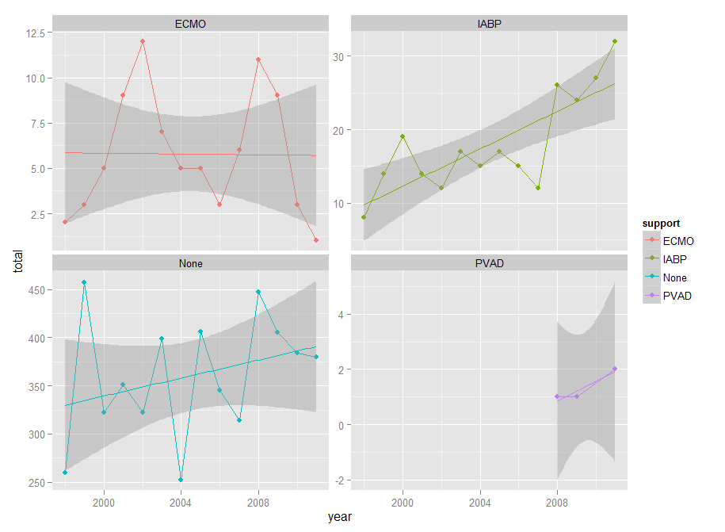

Table 1: Baseline characteristics of patients who underwent cardiac transplant from 1998 to 2011, divided by use of acute mechanical support prior to transplantation

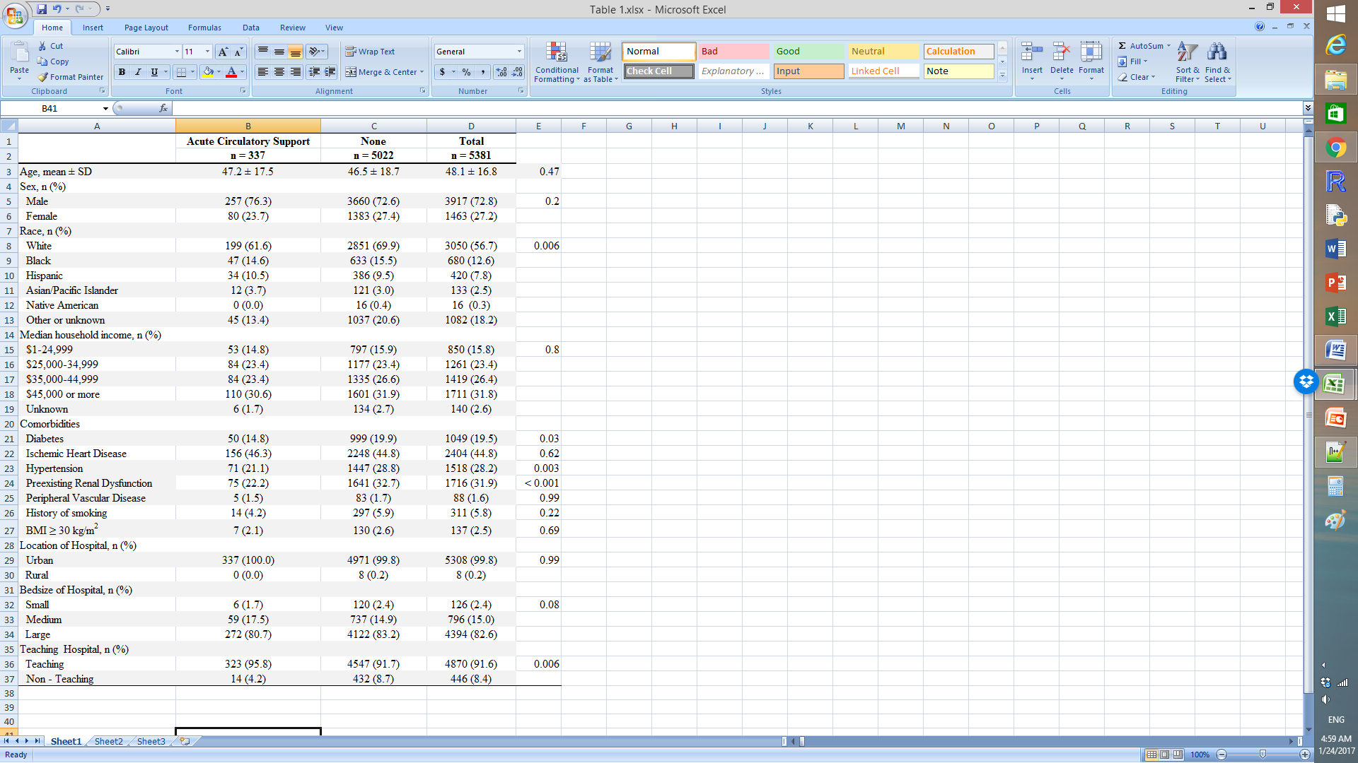

Table 2: Mortality, length of stay, complications in patients who underwent cardiac transplant from 1998 to 2011, divided by use of acute mechanical support prior to transplantation



Supplement A: ICD-9 codes of comorbid conditions

|  |  |
| --- | --- |
| **Comorbidities** | **ICD-9 codes** |
| Diabetes Mellitus | 250.00-250.93, 249.00-249.91 |
| Ischemic Heart Disease | 410.0-410.9, 411.0-411.8, 412, 413.0-413.9, 414.0-414.9, V45.8, V45.82 |
| Hypertension | 401.0-401.9, 402.0, 402.00-402.91, 403.0, 403.00-403.91, 404.0 404.00-404.93, 405.0, 405.01-405.91, 437.2 |
| Pre-existing renal dysfunction | 585.3, 585.4, 585.5, 585.6, 585.9, V42.0, V45.1, V45.11, V45.12, V56.0, V56.1, V56.2, V56.3, V56.31, V56.32, V56.8 |
| Peripheral vascular disease | 440.0-440.9, 443.1, 443.8,443.81, 443.82, 443.89, 443.9, 447.1, V43.4 |
| History of smoking | 305.1, V15.82 |
| BMI > 30 kg/m2 | 278.0, 278.01, 278.02 |

Supplement B: ICD-9 codes of complications

|  |  |
| --- | --- |
| **Complication** | **ICD-9 codes** |
| Post Transplant Circulatory Support1 | 37.61, 37.68, 39.61 |
| Acute Renal Failure | 584.5, 584.6, 584.7, 584.8, 584.9 |
| Acute Liver Failure | 570 |
| Acute Respiratory Failure | 518.81 |
| Cardiac Complications | 997.1, 429.4, 432.0, 432.3, 426.0 |
| Sepsis | 995.91, 995.92 |
| Stroke | 433.0-433.9, 434.0-434.9 |
| Surgical Complication Requiring Reoperation | 340.3, 341, 347.9, 380.3 |
| Bleeding Complication | 530.21 ,456.0 ,530.7 ,530.82 ,578.0 ,578.1 ,578.9 ,456.20 ,531.00 ,531.01 ,531.20 ,531.21 ,531.40 ,531.41 ,531.60 ,531.61 ,532.00 ,532.01 ,532.20 ,532.21 ,532.40 ,532.41 ,532.60 ,532.61 ,533.00 ,533.01 ,533.20 ,533.21 ,533.40 ,533.41 ,533.60 ,533.61 ,534.00 ,534.01 ,534.20 ,534.21 ,534.40 ,534.41 ,534.60 ,534.61 ,535.01 ,535.11 ,535.21 ,535.31 ,535.41 ,535.51 ,535.61 ,535.71 ,537.83 ,562.02 ,562.03 ,562.12 ,562.13 ,569.3 ,569.85 ,537.84 ,569.86 |
|  |  |

1Day of procedure past day of transplant

EXTRA TEXT FROM OLD DRAFTS

, there has been less discussion on

Under the current adult heart allocation system, candidates are stratified in the  highest urgency classification if they require multiple inotropes and hemodynamic monitoring, are supported by total artificial heart, IABP, ECMO, mechanical ventilation, or a ventricular assist device, or are experiencing a MCS device related complication.

There is significant discussion on how to prioritize stable outpatient transplant candidates with a ventricular assist device in compared to hospitalized patients.

in response to increased use of mechanical circulatory support (MCS) devices. With an increasing proportion of heart transplants occurring in patients on MCS,

There exists a variety of acute circulatory support options for decompensated heart failure before and after transplantation. Intra-aortic balloon pump counterpulsation is used as a bridge to heart transplantation with similar 1 year survival outcomes [16,17] and novel approaching including axillary IABP prior to transplant as been proposed [15].

After transplantation, ECMO has been used to bridge and support patients with graft rejection or failure with variable success [12,13,14]. In this particularly sick population, clinical outcomes are poor despite ECMO support with 1 year survival ranging from 19% to 60%[13,14].

In addition

Acute circulatory support options